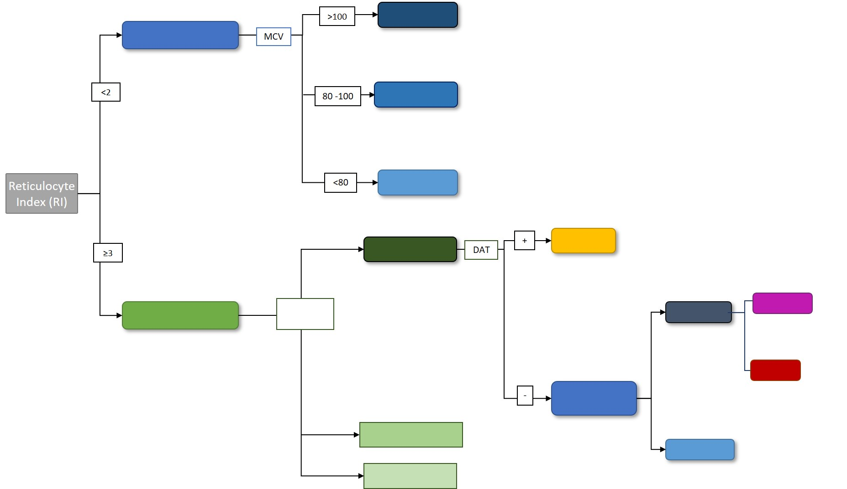

Diagram

Description generated with high confidence