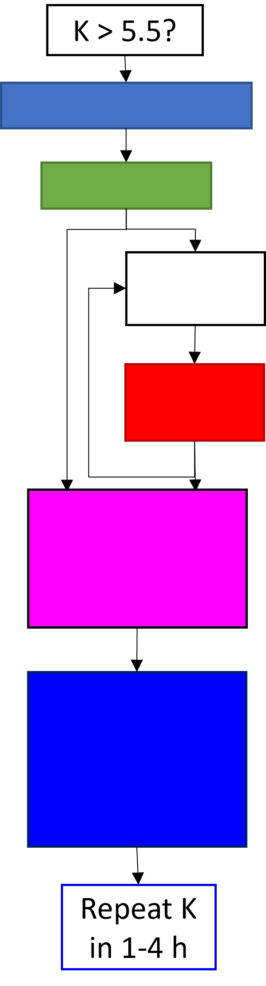
Step 1: ______________________

Step 2: _____________________

Step 3: _____________________

Medication
Dosing
Onset/Duration of action
K
Step 4: _____________________

Step 5: _____________________
Medication | Site of Elimination | Onset/Duration of action | Indications | Contraindications

