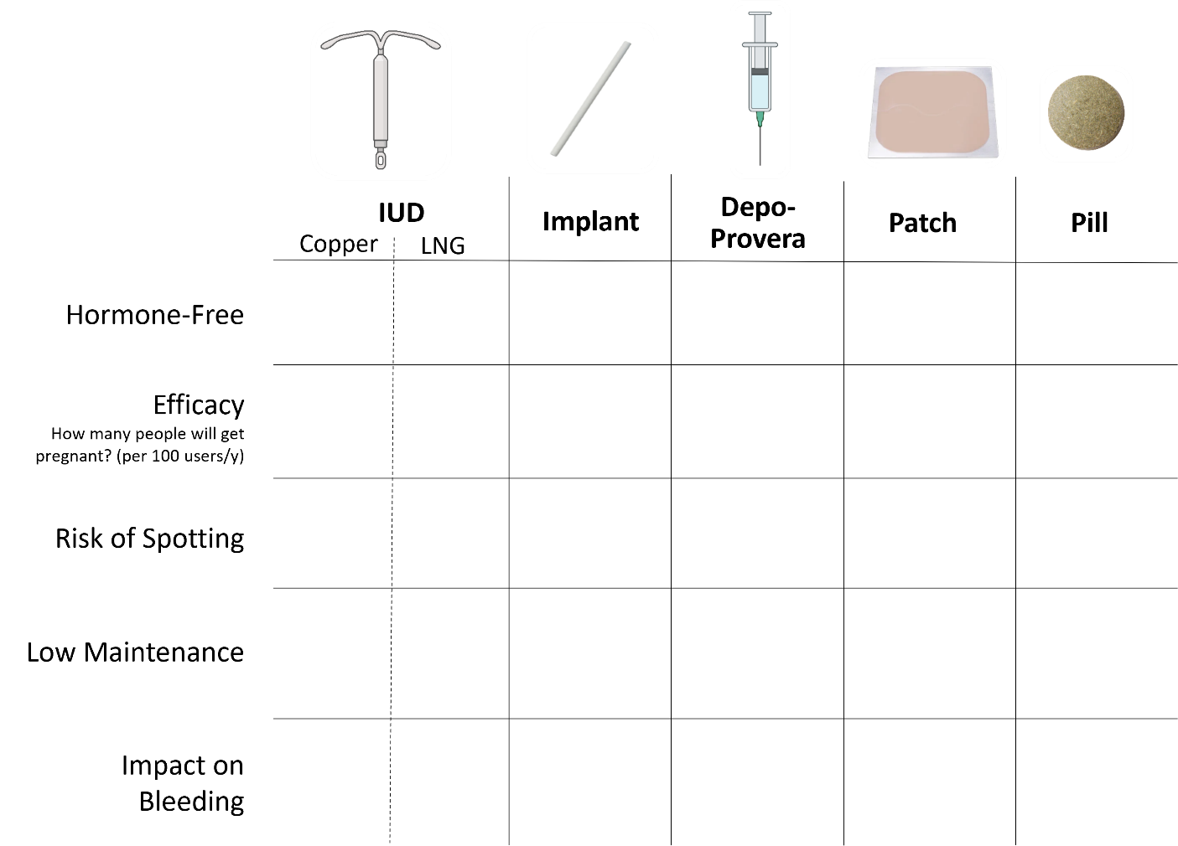
Emergency Contraception
 | Levonorgestrel  (Plan B) | Ulipristal  (Ella) | Copper IUD | Combo OCPs
Safety
Tolerability
Efficacy
Price

Simplicity

