Authors: Natalie deQuillfeldt, MD, Cara Saxon, MD, Kathryn Guinn, MD, Anandi Ramaswami, MD, Christine Haynes, MD, Michelle Cleeves, MD, Nicole Soiseth, MD
Editors: Molly Brett, MD, Adelaide McClintock, MD
Executive Editor: Brandon Fainstad, MD, Yilin Zhang, MD

Objectives:
- Use patient-centered language in history-taking and contraception counseling.
- Employ evidence-based tools to select a method of contraception that meets your patient’s goals.
- Recognize how certain conditions may impact safety and/or efficacy of contraception.

Teaching Instructions:
Plan to spend at least 30-60 minutes preparing for this talk by reading through the information and frequently asked questions below and by becoming familiar with the order of the content that appears on the graphic. We recommend familiarizing yourself with the tabs available in the Contraception app (see QR code on slide 1 to download), particularly the medical eligibility criteria (MEC) tab which provides categories of risk for various conditions to guide risk/benefit discussions. You may wish to check out Bedsider.org as well. The teaching script below details how to walk through the talk. Every interactive or “clickable” element is denoted with a rounded box and cursor icon.

Anticipated time to deliver the talk with and without cases or other features: without cases 15-20 minutes. The cases may take an additional 20-30 min.

Introduction (optional): Importance of this topic
While our population will vary at each clinical site, many of our patients will be women of childbearing age. According to a CDC report, oral contraceptive pills and long-acting reversible contraceptives are amongst the most common forms of contraception in use amongst women (1). In a small study of primary care visits, fifty percent of women needed contraceptive counseling at the time of their visit, those who received counseling were more likely to report use of hormonal contraception, and counseling regarding specific types of contraception was associated with an increased use of those methods (2). These results held up even adjusted for adjusting for age, race, education, income, marital status, pregnancy intentions, prior pregnancy, and prior contraceptive use. By having a conversation about pregnancy attitudes with our patients, we can minimize barriers and empower them to have control over their reproductive health. In turn this will have a huge impact on their work, financial status, and other social determinants of health.

Objective 1: Use patient-centered language in history-taking and contraception counseling. (PATH Questions)
Ask learners to download the contraception app (3) using the QR code and take a minute or two or familiarize themselves with the various tabs.
- PATH questions: Ask learners how we may assess a patient’s attitude towards pregnancy in a patient-centered way that acknowledges that many patients do not have a well-defined plan? How might we inquire about what method a patient would prefer? (4)
- Optional: Use the PATH handout to show examples of conversation starters and examples of language to use during contraception counseling.

Objective 2: Employ evidence-based tools to select a method of contraception that meets your patient’s goals. (Methods and OCP selection)
Methods of contraception: When presenting options, avoid presenting efficacy-first schematics and engage your patient in shared decision-making according to what’s important to them. Start off by matching the benefits/side effects listed on the left side to the appropriate method.
- Benefits/Side effects (Row):
  - Hormone-free – a consideration for patients who may have contraindications to use of hormonal contraception.
  - Efficacy - listed by number of women who will get pregnant per 100 user/year.
  - Low maintenance – frequency of administration.
  - Impact on bleeding/menses - refers specifically to whether periods become lighter or heavier after the spotting duration is complete. The impact on bleeding may not be apparent until 3-4 cycles. Some methods can lead to unpredictable spotting (see below) in the first few months of use (or for duration of use). This graphic shows the impact for the majority of patients after the first few cycles. For example, Nexplanon (implant) will result in decreased bleeding for a majority of patients though a minority of patients may have increased bleeding.
  - Spotting* - this is a category not listed on the formal teaching materials but is included in the learner guide for reference. Many learners are interested in which forms of contraception will cause spotting to help guide counseling with patients. While some forms of contraception are more likely to be associated with spotting (Depo-provera, Nexplanon, and IUDs), the exact duration of spotting is less clear. (Also see FAQ on spotting below)
- Specific methods
  - Copper IUDs tend to make periods heavier and so are usually reserved for women who cannot have hormonal contraception for various reasons, require emergency contraception, or who have lighter, less painful periods and accept the risk of heavier periods.
  - Levonorgestrel (LNG) IUDs and the implant tend to make periods lighter and possibly stop, however some women experience prolonged spotting due to progesterone’s effect on the endometrium (thinning) past the usual spotting duration. If this occurs, it can be treated with oral estrogen if there are no contraindications.
  - Depo-provera will cause most women to have lighter periods to amenorrhea, particularly when used for >1 year, but can be associated with ongoing spotting for the duration of use.
  - The pill and patch tend to lighten periods or keep them the same and are preferred by some patients because they maintain menstrual regularity (having a period every month). Click on “OCP selection” tab in the table of contents to learn more about the dosing OCPs.
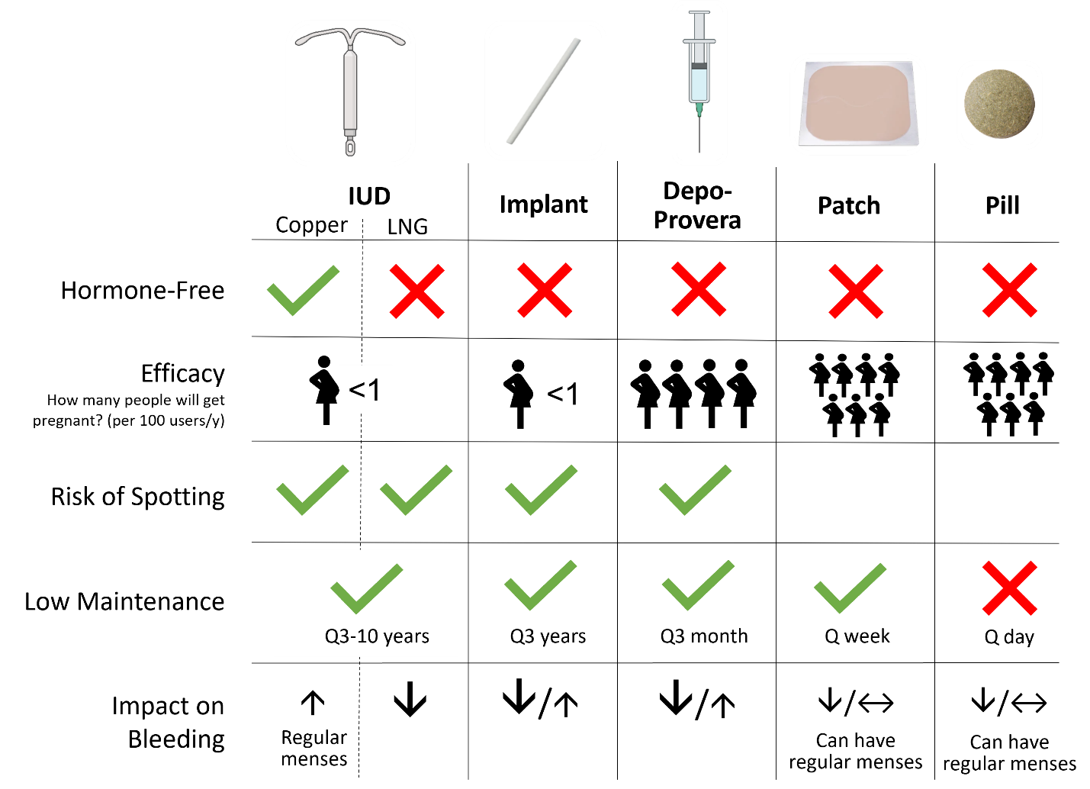

OCP selection: This graphic explains the function of each hormone, typical starting dose for oral contraceptives (OCPs) and how to titrate based upon side effects and/or risks. Click on “estrogen” and “progestin” to reveal additional information.
- Estrogen: It has many functions, of which include suppressing ovulation and stabilizing the endometrium. A common starting dose is 20 mcg/day. Lower doses of estrogen may be associated with breakthrough bleeding and higher doses are associated with increased risk of thrombosis.
- Progestin: Its many functions include thickening of the cervical mucus to inhibit sperm migration, slows the movement of the egg through the fallopian tubes and thins the endometrium to make it less suitable for implantation. While it also suppresses ovulation, breakthrough ovulation can occur with progestin only formulations if the dosing schedule is not followed closely. There are four generations of progestins. Earlier generations tend to have more androgenic side effects. Later generations are associated with higher risk of thrombosis when used in conjunction with estrogens.
- Our experts recommend a starting dose of OCPs is ~ 20 mcg of estrogen in combination with a progestin. Our experts tend to reserve 3rd and 4th generation progestin combinations for patients who need the anti-androgenic properties because of the increased thromboembolic risk. We recommend having 2-3 “favorites” that you recommend each time and then titrate according to individual risk factors and side effects. Here are some options if you wish to share:
  - 20 mcg estrogen + 1st gen progestin: Junel aka Loestrin (Also comes in variations of 10mcg and 30mg estrogen)
  - 20 mcg estrogen + 2nd gen progestin: Lutera OR Amethyst
  - 25 mcg estrogen + 3rd gen progestin: Ortho-Tri-Cyclen Lo OR Tri-Lo-Sprintec (dose of estrogen varies to mimic a naturally occurring cycle).
  - 20 mcg estrogen + 4th gen progestin: Yaz (FYI the FDA has issued warnings about this brand. Several studies have found that Yaz is associated with a 2-3x increased risk of blood clots compared to other OCPs (11-12)).
Bonus: If a OCP it doesn’t have the word Lo in it, it contains 35 mcg of estrogen

If time permits, ask learners to visit https://www.bedsider.org/methods and pretend to counsel their neighbor. Alternatively, participants can be paired and practice asking PATH questions to each other.

Objective 3: Recognize how certain conditions may impact safety and/or efficacy of contraception. (Contraindications and Emergency Use)
- Contraindications: Ask learners which method(s) of contraception would be contraindicated with each of the presented risk factors. (5) Click on each of the icons to reveal contraindications.
- Emergency contraception: While we will be less likely to prescribe emergency contraception, if a patient comes to you for advice or assistance, the STEPS approach can help determine which method would be a good fit for your patient prior to referring them. The primary take-home is Plan B and Ella are the best combination of efficacy and tolerance; copper IUD is the most effective; and combo OCPs the most widely available. The latter method, called the “Yuzpe” method, is not the most effective but has been used in resource-limited areas and is done by combining 100 mcg of ethinyl estradiol and 0.5 mg of levonorgestrel (4-5 pills on average). Specific number of pills for common brands can be found at Bedsider.org (10).
- Bonus: LNG IUD has been shown to be noninferior to copper IUD for emergency contraception but is not yet FDA approved for this indication (16).

Cases: Print out the Cases handout and break out into small groups to work through the cases.

Take Home Points:
- In general, ask open-ended questions when gauging patients’ interest in pregnancy and avoid assumptions about their goals.
- The Contraception app and Bedsider.org can assist your patient in selecting a method that is right for them.
- Obtain a thorough personal and family history to assess risk factors and contraindications. When in doubt, use the US Medical Eligibility Criteria (MEC) tab of the app for guidance.

Frequently Asked Questions:
- Explain why multiphasic OCPs exist –Multiphasic pills (varying doses of either of both hormones in each pill) were introduced as a strategy to reduce hormone-related side effects/spotting and for market-related competition, but data shows there is no important clinical advantage and in fact biphasic pills are associated with more unscheduled bleeding and are thus not used. I think for the purposes of the presentation would stick to monophasic pills and the two strategies of prescribing (cyclic with monthly menses vs continuous with menses Q3 months) (13).
- The difference between the generations of progestins and whether the choice really matters – The 3rd and 4th gens are theoretically more anti-androgenic and therefore are better options for patients with hirsutism and hormonal acne. However, these later generations also carry an increased risk of thrombogenicity when combined with estrogen. Therefore, if you or your patient are worried about clot prevention, you may consider an earlier generation of progestin combination (Junel or Lutera) and add on spironolactone orally for treatment of androgenic side effects.
- How do progesterone methods prevent regular periods? When progesterone decreases in the menstrual cycle, spiral arteries collapse, and the endometrium sloughs off. When using progesterone-only birth control methods, the level of the hormone remains high, so this sloughing never occurs, and the patient therefore does not have regular menses.
- Specific efficacies with typical use: 99.98+% with LNG IUD, 99.92+% with copper IUD (women under 25 experience slightly higher failure rate due to increased fertility but comparable to surgical sterilization) (14). Reported efficacy of Depo-provera is 99.3% but typical use has an unintended pregnancy rate of 6%. Pregnancy rates for the patch are 1.07-8.6%. Typical use failure rate for OCP is approx. 7% (with perfect use 0.3%), 5% for POP (unclear data on perfect use failure rate). The most effective method to date is the implant, with a pregnancy rate of 0.05 per every 100 people with this method (15).
- Why is 2nd generation levonorgestrel the formulation used in IUDs if the 3rd and 4th generations have a better side effect profile? Levonorgestrel is the hormone in progestin IUDs because it was found to be efficacious. The long answer is: levonorgestrel was synthesized first in 1970, 11 years before the first 3rdgeneration progestin was synthesized (desogestrel, 1981, norgestimate 1986, etonogestrel 1998, and drospirinone 2000) and the studies looking into progestin IUDs began in 1974. The Finnish team that ultimately developed and studied levonorgestrel IUDs tried a couple of other hormone and IUD shape combinations throughout the mid-70s that didn’t work for various reasons and landed on the combination of LNG and the “T” shape IUD we know today in 1976, leading to a successful pilot study in 1977 and approval of the LNG IUD in Finland in the 1980’s and FDA approval in 1990. Given how long it took to get this to market, the fact that the negligible systemic absorption of levonorgestrel minimized the side effects associated with systemic LGN, and the overall popularity of the device, there has been little effort at repeating the process with the newer generations of progestins.
- Spotting is one of the number one reason why patients stop their method early. Why do so many methods cause this as a side effect? Methods without an estrogen component are more prone to causing spotting for 6-12 months, whereas the combination methods lead to more rapid adjustment usually within 3 months. The spotting that can come with initiation of combined methods is due to perturbation in the hypothalamic-pituitary-ovarian axis which resolves quickly (2-3 months) once the uterus is being affected only by the synthetic hormones and no longer affected by endogenous hormones. When people have spotting after that few months on low dose combines contraception, it is usually because there is too little estrogen to counteract the progestins effect. In addition, progestin elongates the spiral arteries, and it also prevents buildup of the endometrium, so those spiral arteries are exposed to the surface of the uterus and cause a slow bleed, which is why spotting is so much more common with progestin-only methods.

References:
- Daniels, K., & Amba, J. C. (n.d.). Current contraceptive status among women aged 15–49: United States, 2017–2019. CDC.gov. Retrieved February 26, 2022, from https://www.cdc.gov/nchs/data/databriefs/db388-H.pdf
- Lee, Jessica K et al. “The impact of contraceptive counseling in primary care on contraceptive use.” Journal of general internal medicine vol. 26,7 (2011): 731-6. doi:10.1007/s11606-011-1647-3. Accessed at https://www.ncbi.nlm.nih.gov/pmc/articles/PMC3138576/
- Steinberg, J, Holms, K. Contraception Point-of-Care. Copyright 2020 Steinberg et Holms. Available for download at https://apps.apple.com/us/app/contraception-point-of-care/id1212014869
- Callegari LS, Aiken AR, Dehlendorf C, et al. Addressing potential pitfalls of reproductive life planning with patient-centered counseling. Am J Obstet Gynecol 2017; 216:129. Tool available from the Reproductive Health National Training Center at https://rhntc.org/resources/client-centered-reproductive-goals-counseling-flow-chart
- Ramaswami A, Cleeves M. Contraceptive Counseling in 10 Acts. 2021.
- Jasani S, Balica A, Marshall I, Ayers C, Bachmann G, Francis A. Pregnancy Risk, Contraception and Sexually Transmitted Infections in the Transgender Patient [4F]. Obstetrics & Gynecology. 2017; 129 62S-63S. doi: 10.1097/01.AOG.0000514833.08281.ee.
- Curtis KM, Jatlaoui TC, Tepper NK, et al. U.S. Selected Practice Recommendations for Contraceptive Use, 2016. MMWR Recomm Rep 2016; 65:1.
- Westhoff C, Heartwell S, Edwards S, et al. Initiation of oral contraceptives using a quick start compared with a conventional start: a randomized controlled trial. Obstet Gynecol 2007; 109:1270.
- Lopez LM, Newmann SJ, Grimes DA, et al. Immediate start of hormonal contraceptives for contraception. Cochrane Database Syst Rev 2012; 12:CD006260.
- “The Yuzpe Method: Effective Emergency Contraception Dating Back to the '70s.” Bedsider, 9 Dec. 2010, www.bedsider.org/features/88-the-yuzpe-method-effective-emergency-contraception-dating-back-to-the-70s.
- Parkin L, Sharples K, Hernandez RK, Jick SS. Risk of venous thromboembolism in users of oral contraceptives containing drospirenon or levonorrgestrl: nexted case-control study based on study based on UK General Practice Research Database. BMJ 2011; 342:d2139.
- Jick SS, Hernandez RK. Risk of non-fatal venous thromboembolism in women using oral contraceptives containing drospirenon compared with women using oral contraceptives containing levonorgestrel: case-control study using United States claims data. BMJ 2011; 342:d2151.
- Allen, R. H. (2022, February). Combined estrogen-progestin oral contraceptives: Patient selection, counseling, and use. UpToDate.
- Steiner MJ, Trussell J, Mehta N, et al. Communicating contraceptive effectiveness: A randomized controlled trial to inform a World Health Organization family planning handbook. Am J Obstet Gynecol 2006; 195:85.
- Sundaram A, Vaughan B, Kost K, et al. Contraceptive failure in the United States. Perspect Sex Reprod Health 2017; 49:7. Reproduced from: Family Planning National Training Center. Birth Control Methods Options Chart. Available at: www.fpntc.org/resources/birth-control-methods-options-chart
- Turok DK, et al. Levonorgestrel vs. Copper Intrauterine Devices for Emergency Contraception. NEJM. 2021; 384:335-344.
- Robinson JA & Burke AE. Obesity and hormonal contraceptive efficacy. Women's Health (Lond Engl). 2013. 9(5):453-466.

